1. Create an image from running container.

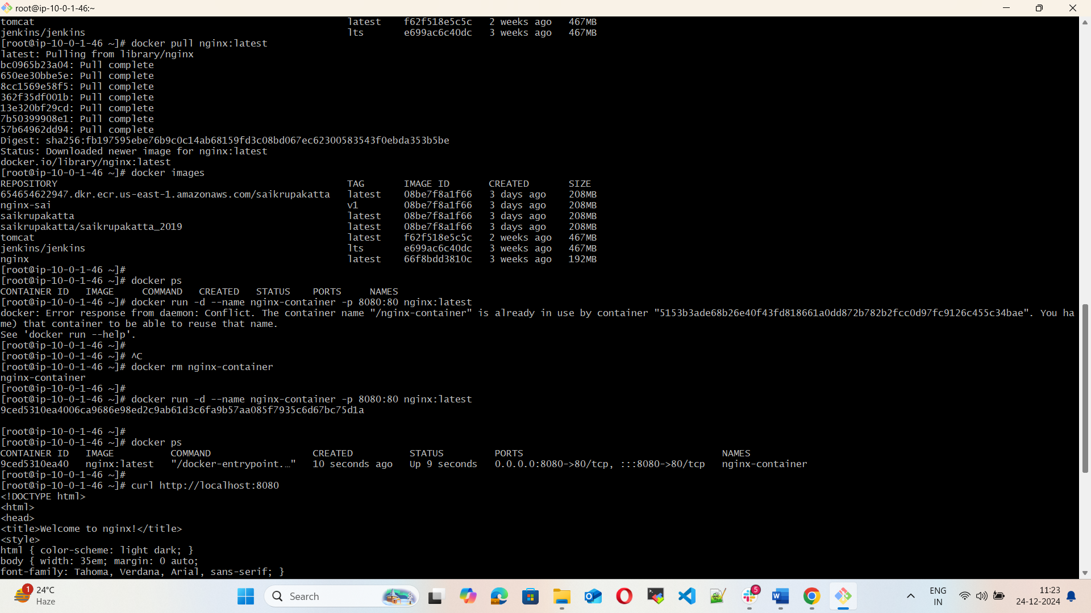

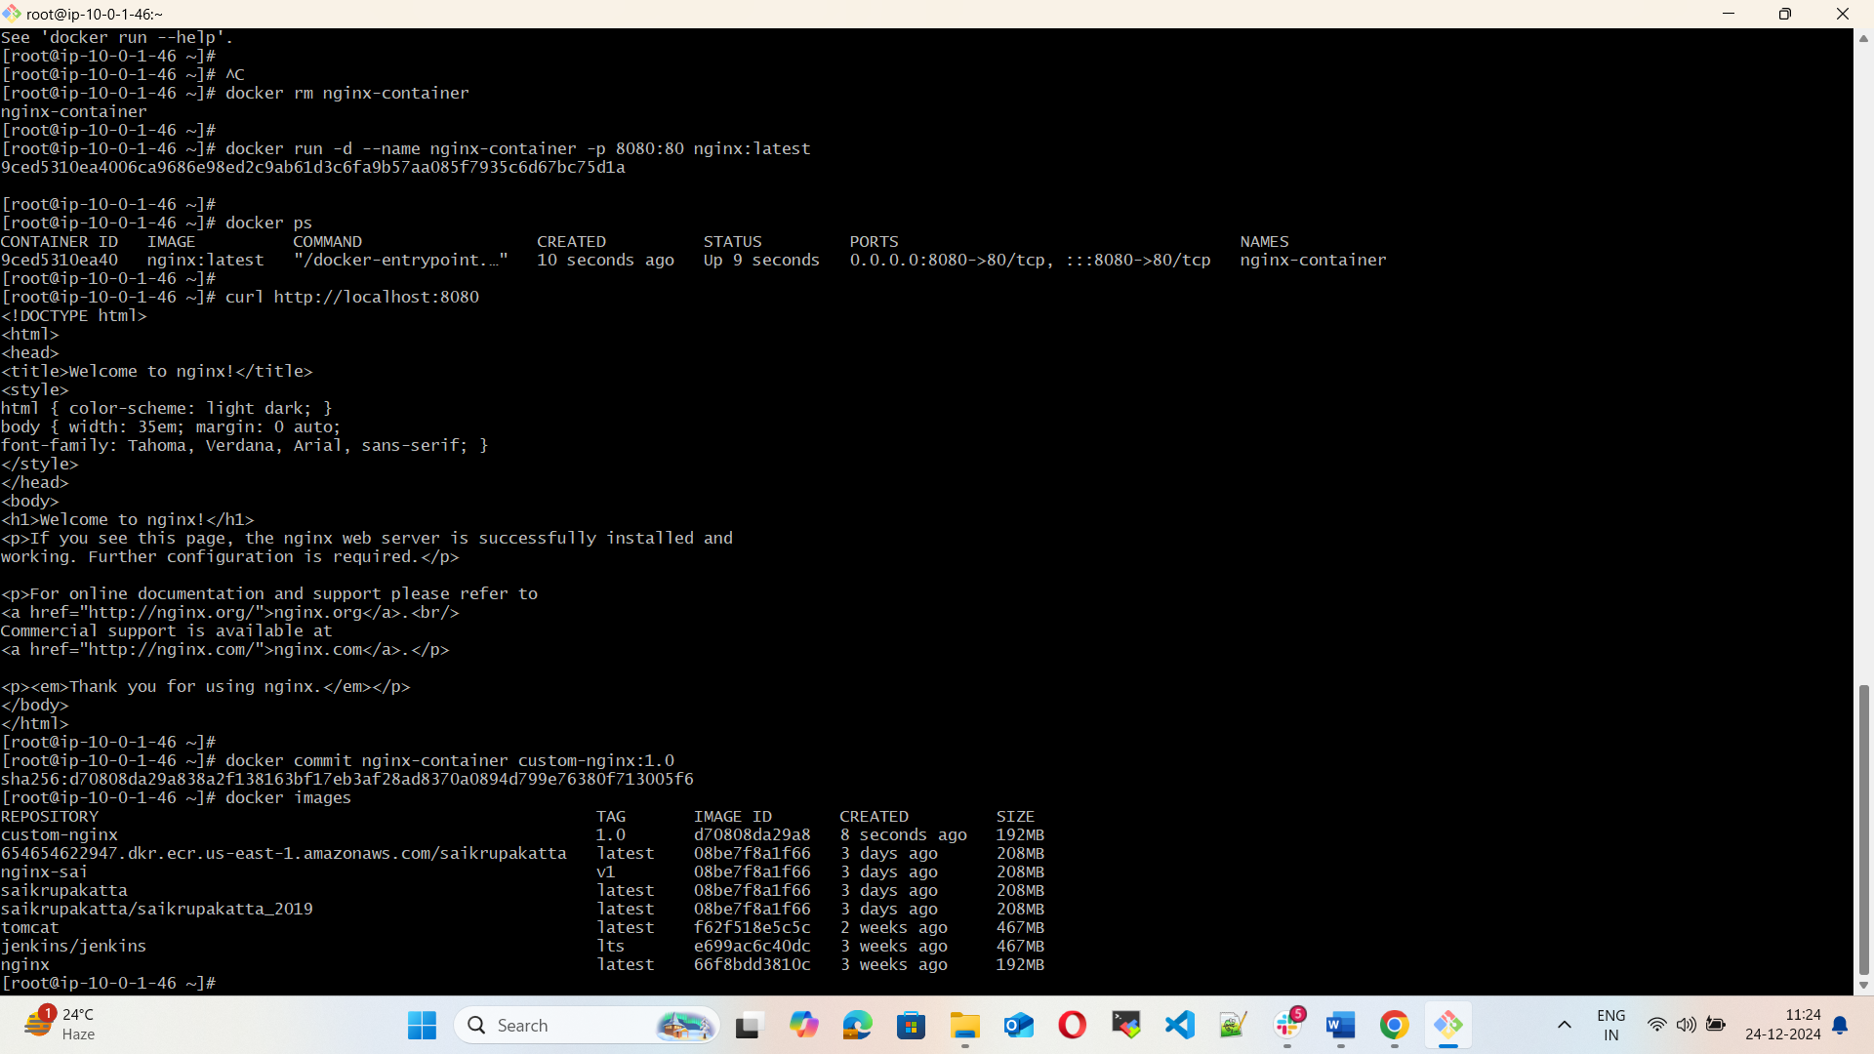

2) Copy image from local machine to docker server and load the image.

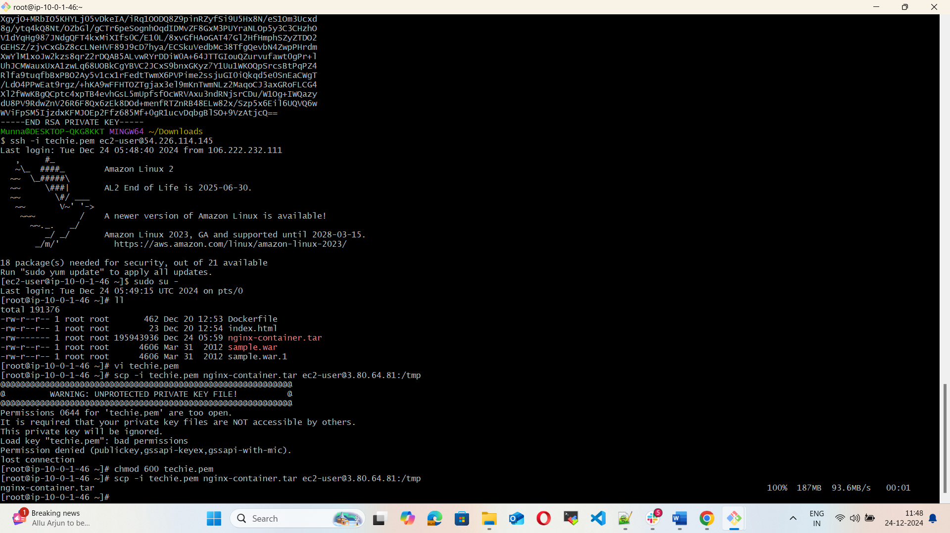

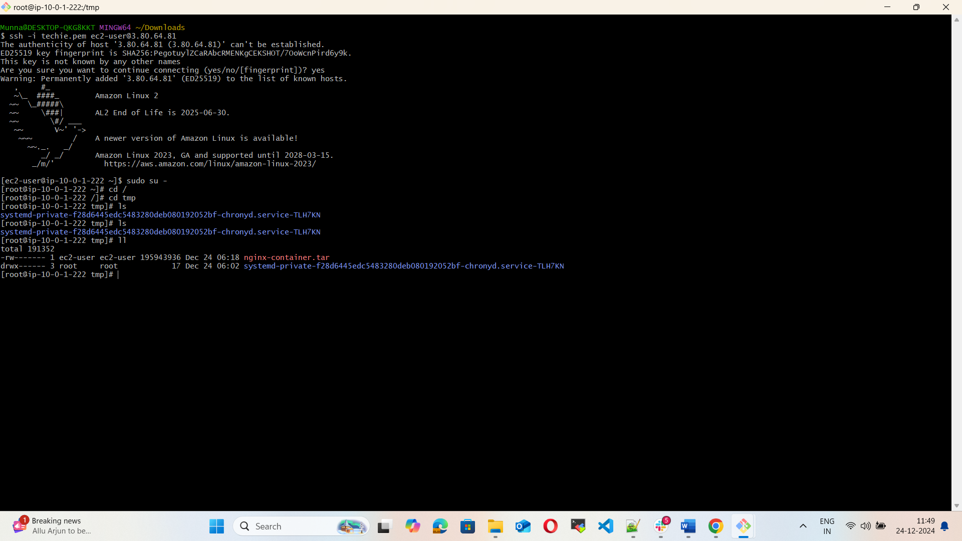

3) Create Docker image using alpine and customize with tomcat.

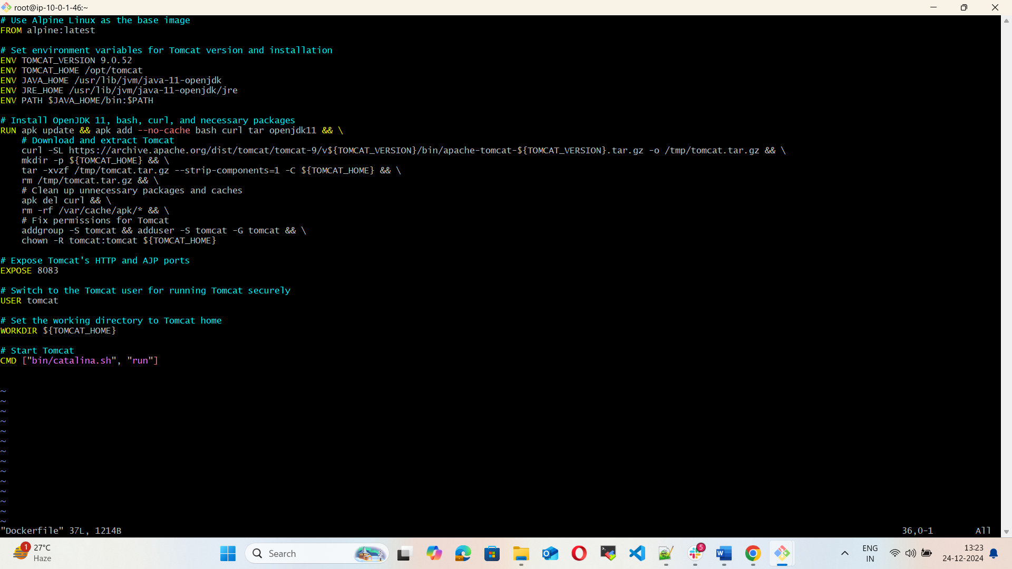

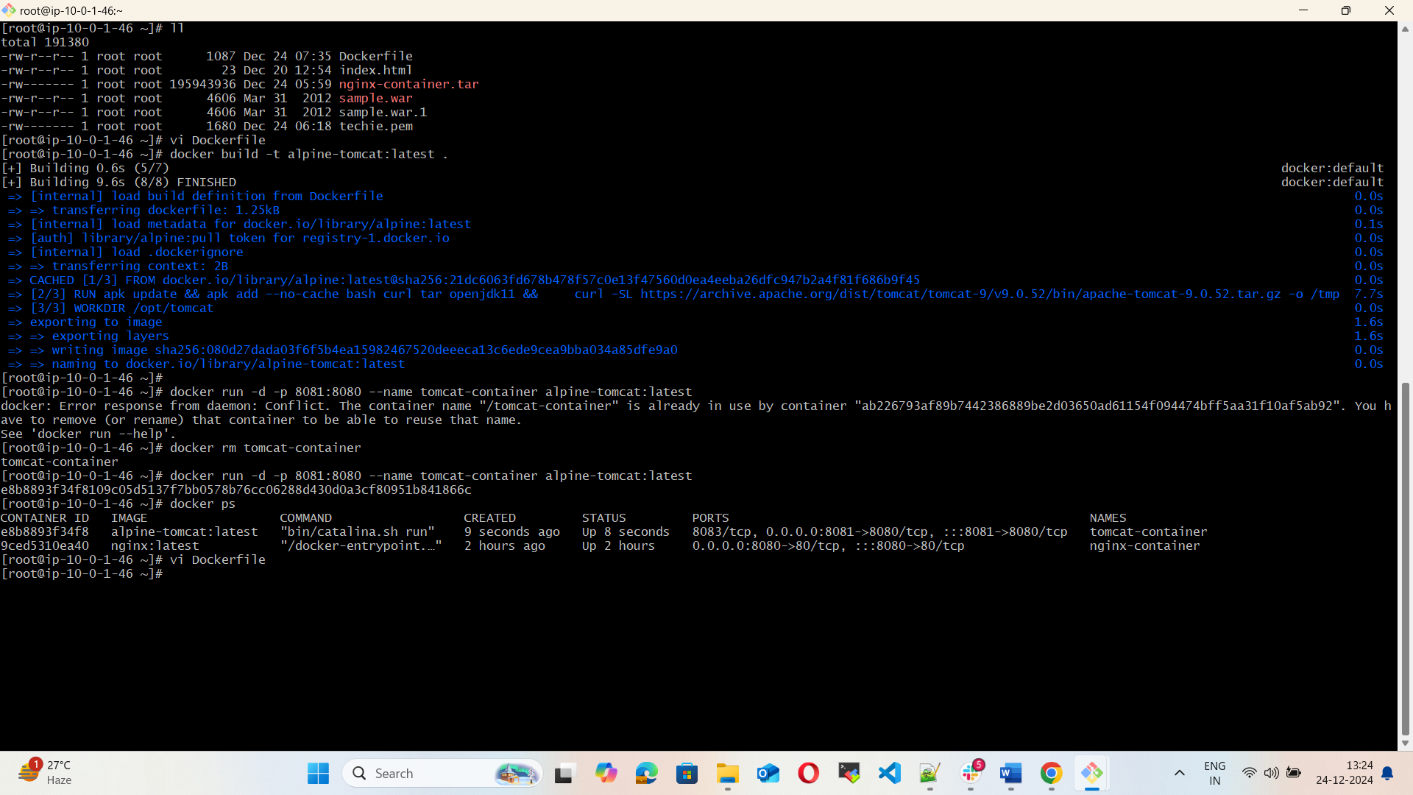

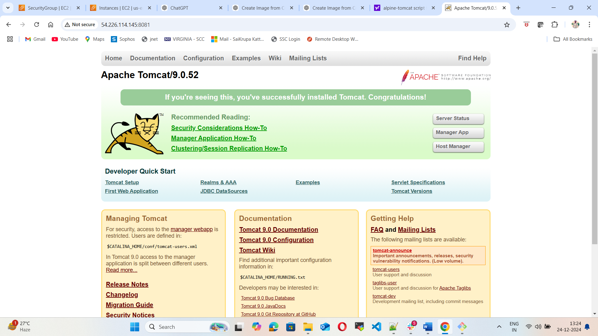

4) Create single stage and multi stage docker file using the below source code.  
   <https://github.com/betawins/multi-stage-example.git>

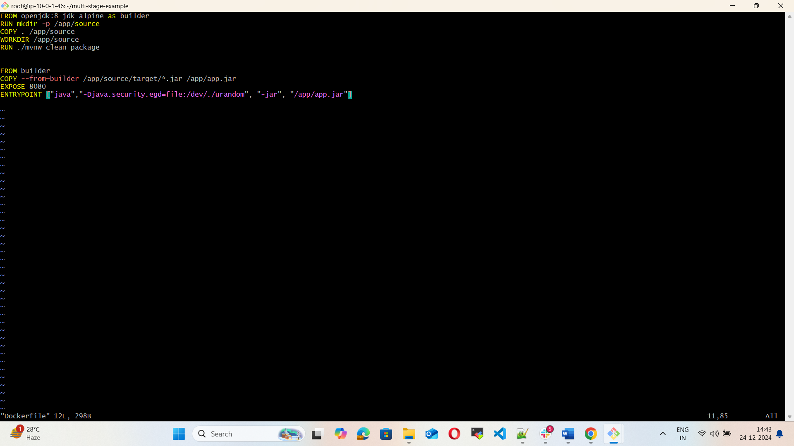

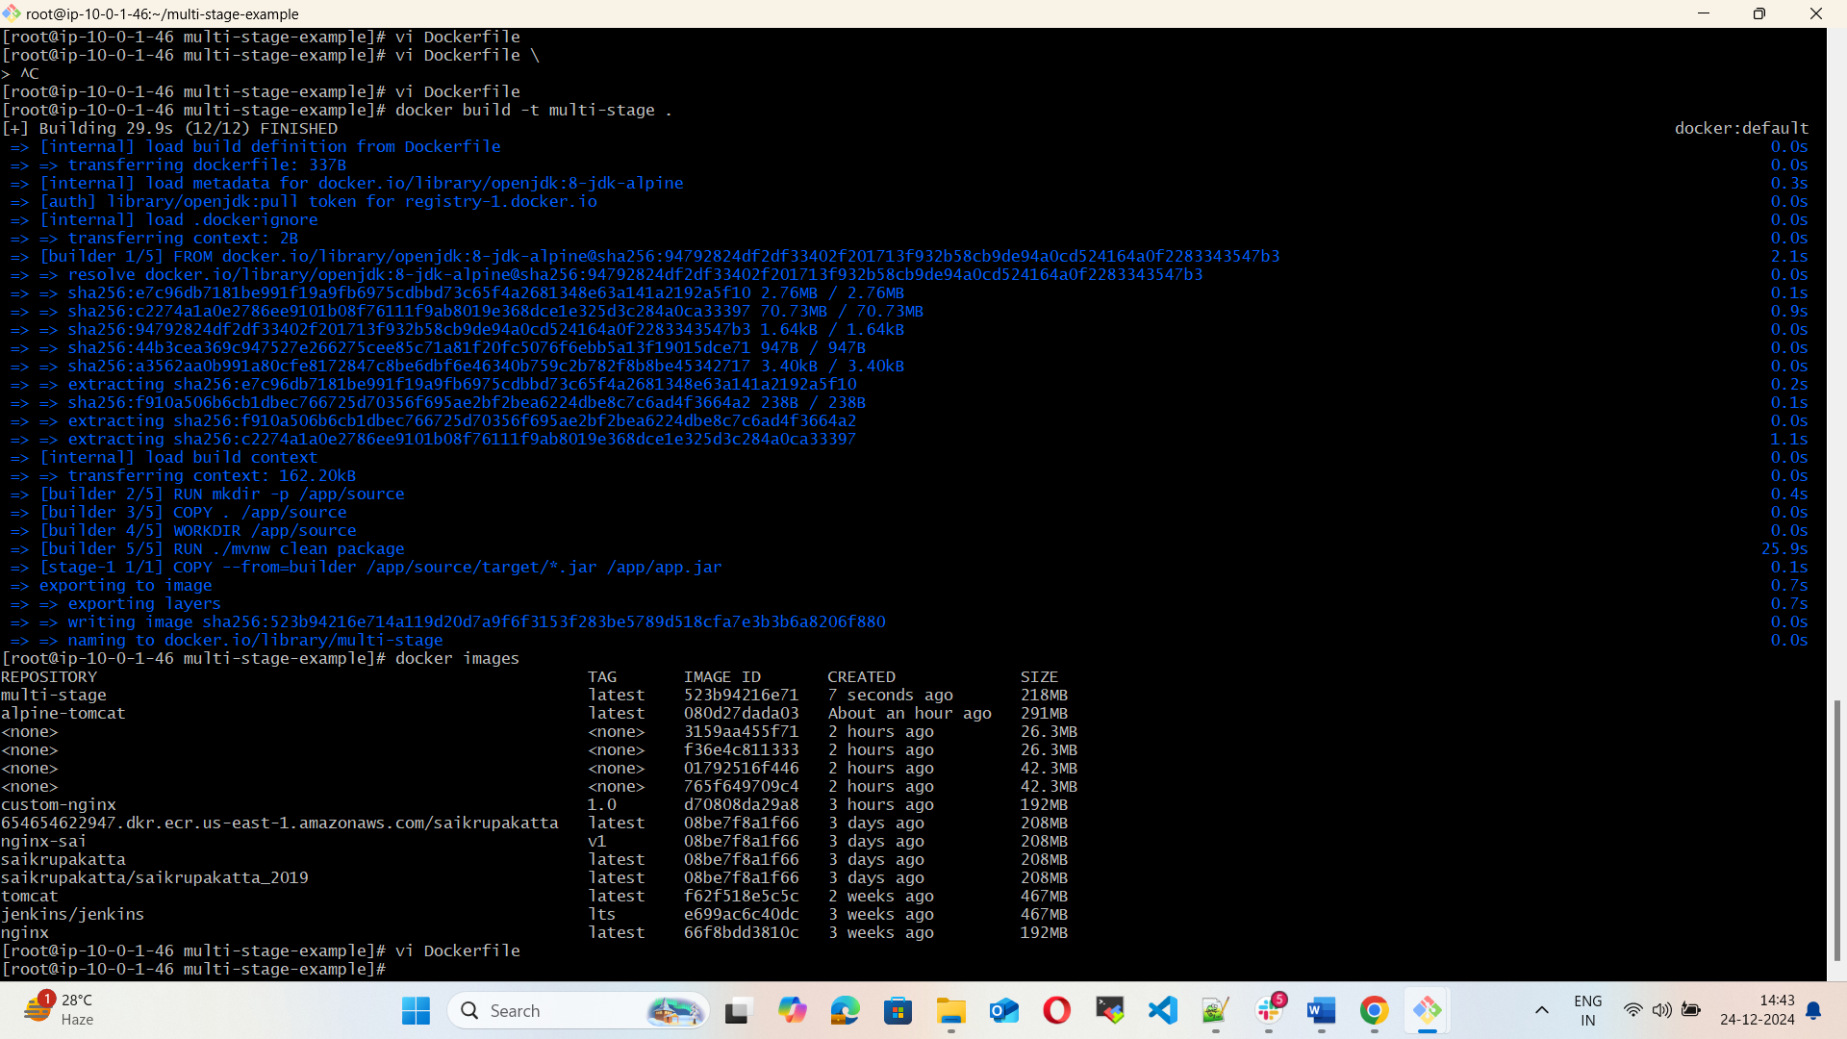

5) Install docker compose and execute sample application.

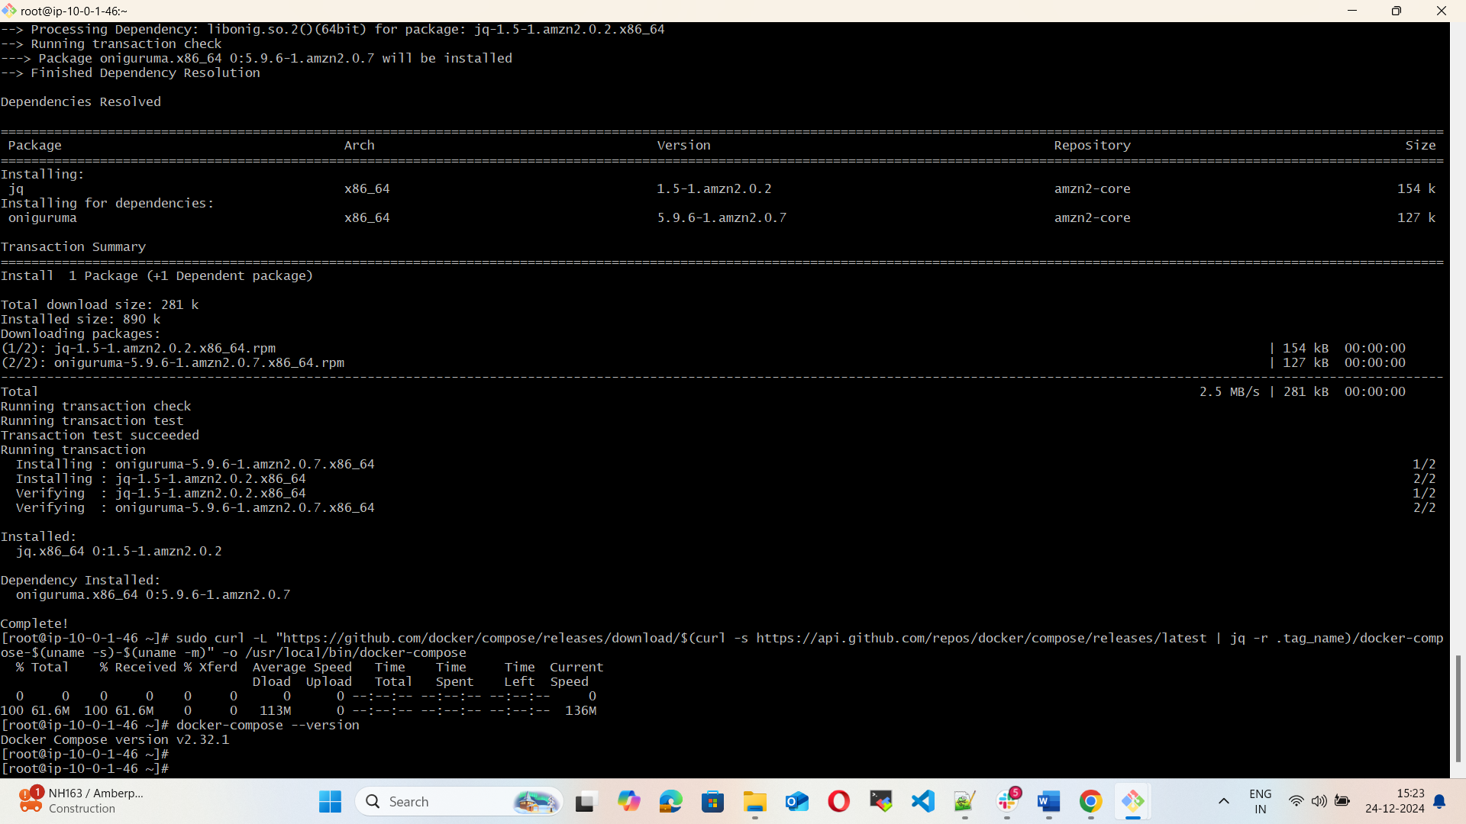

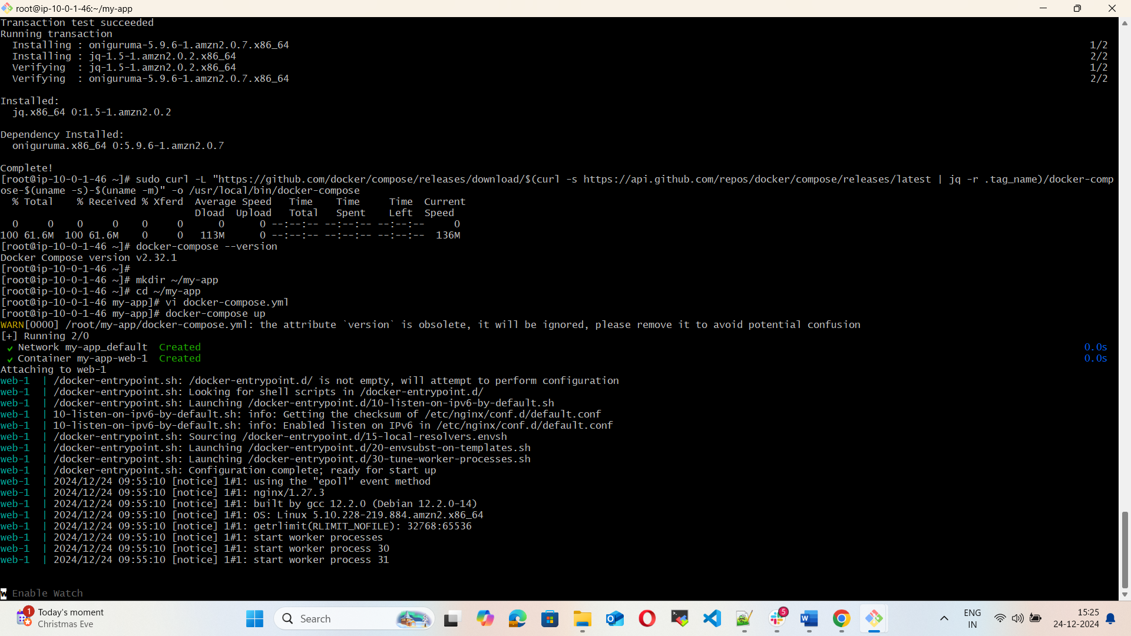

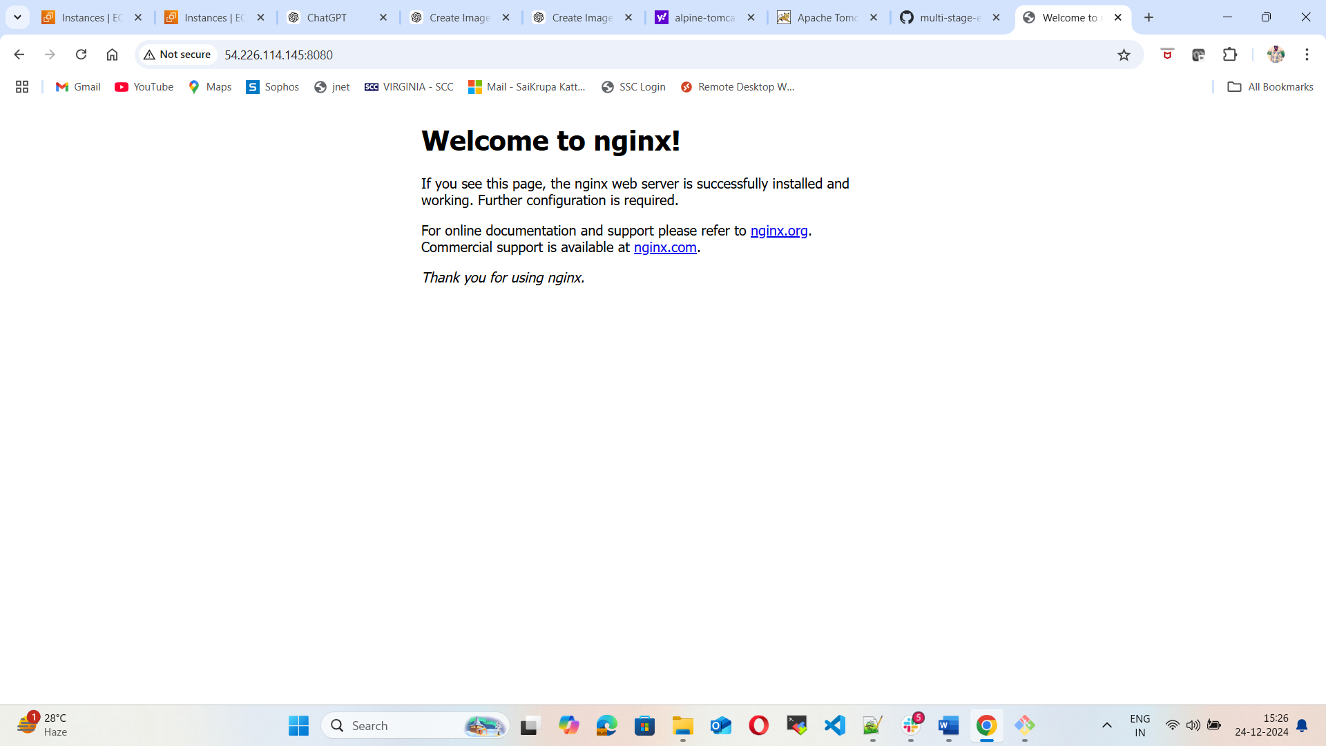

6) Implement solution to scan images when pushed to docker registry.  
7) Implement solution to scan images when pushed to aws ecr.    
8) Create a Jenkins pipeline to create a docker image and push the image to docker hub.